1 Implementation of a custom NavMesh path with checkpoints.

2 Script to control the sequence of audio lines.

3 Completed the animation sequence of the dream scene. Added audio lines, AI navigation and Character Animations.

4 "Runner" parent class for both hare and turtle script.

5 Colourful particle system.

6 Following a merge with scott's branch, started implementing the features in the bedroom. Created a “GenericWondrousObject” script. This script will manage the features of objects that can be picked up and positioned to a target location. Each wondrous object will inherit from this script and apply their own special effects. The target location will be highlighted to the player by an “indicator” object.

7 The indicator for each wondrous object's target location is a particle system in the shape of the object.

8 Added a fade to/from black effect between the transitions of the scenes.

9 Added a toy gun that shoots on grab activated.

10 Script for the shooting event. The hit detection will be implemented with collision with the actual bullet prefab.

11 Script to randomise the colour of the bullet.

12 Slime asset for the shooting event. Used the Lazy Follow script to make it face the main camera.

13 Animator for the slime.

14 When a bullet hits a slime.

15 Removed the LazyFollow component and implemented a custom smooth “lookat” script.

16 Event Manager script for enabling and disabling each event.

17 Created indicator for the toy gun.

18 Added particle effect on the appearance of the slimes.

19 Broom transformation into sword.

20 Create train animation with particle systems. Made a railroad system with tracks that appear gradually.

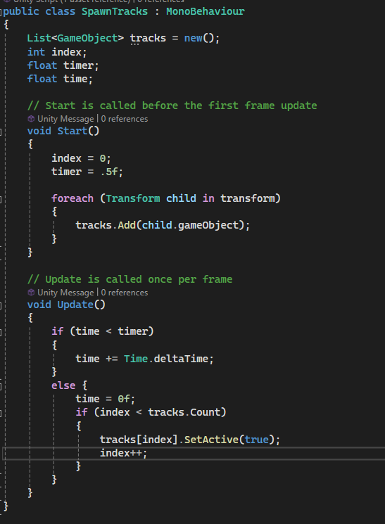

21 Script to make tracks appear one at a time.

22 Implemented tracks despawning in reverse order

23 Added floating apples to the sword event that implement the EzySlice algorithm.